AI Governance Evidence Infrastructure:
Cognitive Insight Audit Framework Lazy Capsule Materialization (CIAF - LCM)
  - From Governance Policy to Lifecycle Receipts, Gates, and Vaulted Evidence
Denzil Greenwood
Founder and Head Researcher, CognitiveInsight.ai
April 2026

Abstract
This paper defines CIAF - LCM as the standalone process model inside AI Governance Evidence Infrastructure logic, while the later “with Governance Gates” paper focuses on the operational receipt and gating mechanics. Its core contribution is to show how organizational governance policy becomes executable governance rather than remaining passive documentation. In the CIAF - LCM process, governance policy is versioned as a governed artifact, translated into machine - evaluable logic, instantiated as gates, applied to AI lifecycle events, and preserved alongside receipts in the evidence vault. That sequence - policy, logic, gates, events, receipts, vault - explains the operating mechanism of the architecture. The result is a process model in which lifecycle evidence is tied to the exact policy state under which it was evaluated, making audit, regulatory review, incident reconstruction, and dispute handling materially stronger. The paper further distinguishes CIAF - LCM from generic logging, observability, policy repositories, and workflow automation by framing it as a policy - grounded evidence process that binds organizational intent to machine - validatable control and durable, independently reviewable records.

1. Governance as the Starting Point
Organizations already maintain governance processes to manage risk, assign accountability, define control requirements, and oversee how systems are designed, deployed, and monitored. In the AI context, that governance usually appears through policy documents, standards, review committees, approval workflows, control libraries, escalation paths, and monitoring practices. These mechanisms may differ by sector and maturity, but they all answer the same basic questions: what is in scope, who is responsible, what conditions must be satisfied, and how exceptions or incidents are handled.
CIAF - LCM is designed to complement and operationalize that existing governance structure, not replace it. It begins with the organization’s own governance policy and treats that policy as a first - class control artifact. The policy defines which AI lifecycle events are in scope, which controls apply, what evidence must exist, and which conditions must be satisfied before particular actions, transitions, or deployments are allowed.
Within CIAF - LCM, governance policy is versioned, preserved, and translated into machine - evaluable logic. That logic is then used to derive governance gates that can be applied consistently across lifecycle events. In this way, governance moves from static documentation into runtime - capable control. Events are evaluated against the applicable policy version, and the resulting outcomes—such as approval, denial, escalation, or inspection—are preserved as receipts alongside supporting evidence in the evidence vault.
This is why CIAF - LCM must be understood as more than an event - capture model. It is a governance process that connects organizational intent to machine - verifiable control and durable evidence. Without this framing, readers may incorrectly interpret gates as generic approval checkpoints, workflow controls, or ad hoc rules. A dedicated CIAF - LCM process paper clarifies that gates are the runtime expression of versioned governance policy and that receipts preserve the relationship between lifecycle events, policy state, and control outcomes.

2. CIAF - LCM as a Policy - Grounded Lifecycle Evidence Process
The central claim of CIAF - LCM is that AI governance becomes operational when policy is not merely written, but structured so that the system can validate lifecycle events against it and preserve the outcome as evidence. This makes CIAF - LCM a process architecture rather than a logging pattern. Its job is not only to record that events occurred, but to preserve how those events were governed, under which policy version they were evaluated, and what control outcome resulted.
This distinction is important because several adjacent categories can look similar at first glance. CIAF - LCM is not a generic observability framework; observability is primarily concerned with understanding system state and behavior. CIAF - LCM is not merely a policy repository; a stored policy document by itself does not produce machine - validatable runtime control. CIAF - LCM is not only a workflow engine; workflow sequencing alone does not create durable, independently verifiable evidence. Instead, CIAF - LCM binds policy state, lifecycle events, control evaluation, and preserved evidence into one continuous chain.
Seen this way, CIAF - LCM supplies the operating logic for the broader AGEI concept. It explains how the architecture moves from organizational governance intent to executable control logic, to gated evaluation, to portable receipts, and finally to durable evidence suitable for audit, regulatory review, incident reconstruction, or litigation readiness.

3. Core Process Sequence
The CIAF - LCM process can be understood as a nine - step sequence that moves from organizational governance intent to machine - validatable control and finally to durable evidence preservation.
Step | Process description
1 | Define governance policy at the enterprise, system, model, workflow, or use - case level.
2 | Version the policy and preserve it as an evidence - bearing artifact.
3 | Translate the policy into machine - evaluable logic, including conditions, thresholds, approvals, exceptions, and required evidence elements.
4 | Derive governance gates from that policy logic.
5 | Capture all policy - defined lifecycle events inside the governance perimeter.
6 | Canonicalize, hash, and structure those events into receipts.
7 | Evaluate the event against the applicable policy version and emit an outcome such as approve, deny, escalate, or inspect.
8 | Commit the receipt, policy version, and linked evidence references into the evidence vault.
9 | Support retrieval, audit, investigation, dispute handling, and regulatory review from the preserved chain of evidence.

Figure 1. CIAF - LCM process chain
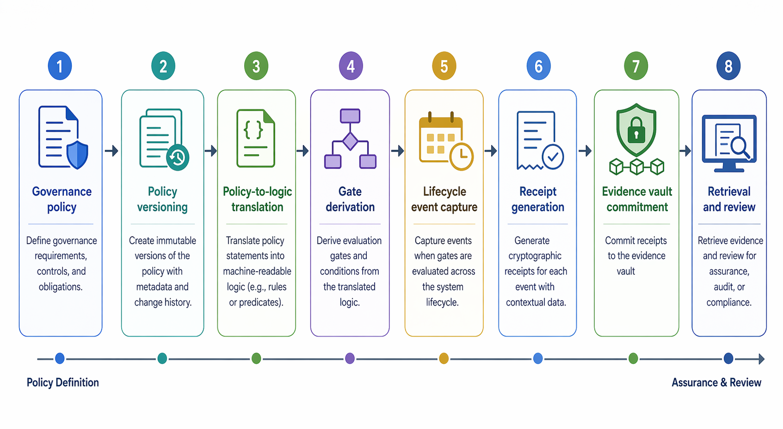
Figure 1. CIAF - LCM process chain
: Governance policy - > policy versioning - > policy - to - logic translation - > gate derivation - > lifecycle event capture - > receipt generation - > evidence vault commitment - > retrieval and review.

4. Policy as a First - Class Artifact
The starting point is governance policy. An organization may maintain a single enterprise policy, model - specific policies, workflow - specific policies, or a layered combination of all three. What matters is that the policy defines the governance perimeter: which lifecycle events are in scope, what conditions apply, what approvals are required, and what evidence must be retained.
In CIAF - LCM, policy is not background documentation. It is versioned, governed, and committed to the evidence vault in the same way that lifecycle evidence is preserved. This matters because later review must be able to answer not only what happened, but what governing rules were in force when it happened. A deployment that looked acceptable under one policy version may be unacceptable under another; an investigation or regulator must be able to reconstruct that state without relying on memory or narrative inference.
Once policy is treated as an evidence - bearing artifact, gates become legible. They are no longer arbitrary checkpoints; they are run-time enforcement points derived from policy states. This is one of the most important conceptual shifts in the paper series: CIAF - LCM is not simply recording actions after the fact, it is preserving the policy context that shaped those actions.

5. Policy - to - Logic Translation
Human - authored governance policy must be translated into machine - evaluable logic. In practice, that means conditions, thresholds, approvals, exceptions, routing rules, and evidence requirements that the AI process can validate against. This translation may take the form of rules, declarative schemas, validation expressions, approval policies, or orchestrated control logic, depending on implementation. The specific format is less important than the architectural requirement: the policy must be rendered into a form that can be evaluated consistently and reproducibly.
The purpose of this translation is not to remove human governance. It is to make governance executable. A policy that cannot be evaluated at runtime remains interpretive guidance; a policy that can be evaluated at runtime can produce enforceable gates and evidence - bearing outcomes. This helps organizations move from stated governance intent to operational governance action.
Versioning is critical here. The logic must remain traceable to the exact policy version that authorized, restricted, or escalated the event. Otherwise, later reviewers can see that a gate fired but cannot prove which governing rules produced that result. CIAF - LCM therefore treats policy - to - logic translation as part of the evidence process, not merely as an engineering implementation detail.

6. Gate Derivation and Lifecycle Evaluation
Gates are derived from the translated policy logic. They may appear at data onboarding, training, validation, deployment, runtime action, incident handling, or other consequential lifecycle transitions. Their purpose is not simply to pause a workflow. Their purpose is to evaluate whether the conditions defined by policy have been satisfied before a consequential event is permitted to proceed.
Every policy - defined lifecycle event is captured inside the governance perimeter. The key distinction is not whether the event is captured, but how the event is preserved and evaluated. CIAF - LCM captures the event, canonicalizes it, hashes it, and structures it into a receipt that can later be retrieved and verified. When the event reaches an applicable gate, it is evaluated against the relevant policy version. That evaluation yields an outcome such as approve, deny, escalate, or inspect. The outcome is not a transient runtime fact; it becomes part of the evidence chain.
This is what makes gates different from generic checkpoints. A generic checkpoint may record that someone approved something. A CIAF - LCM gate preserves the relationship between event, policy state, evaluation logic, and outcome. That relationship is what later makes audit, challenge, reconstruction, and dispute handling materially stronger.

Figure 2. Policy version to gate outcome relationship
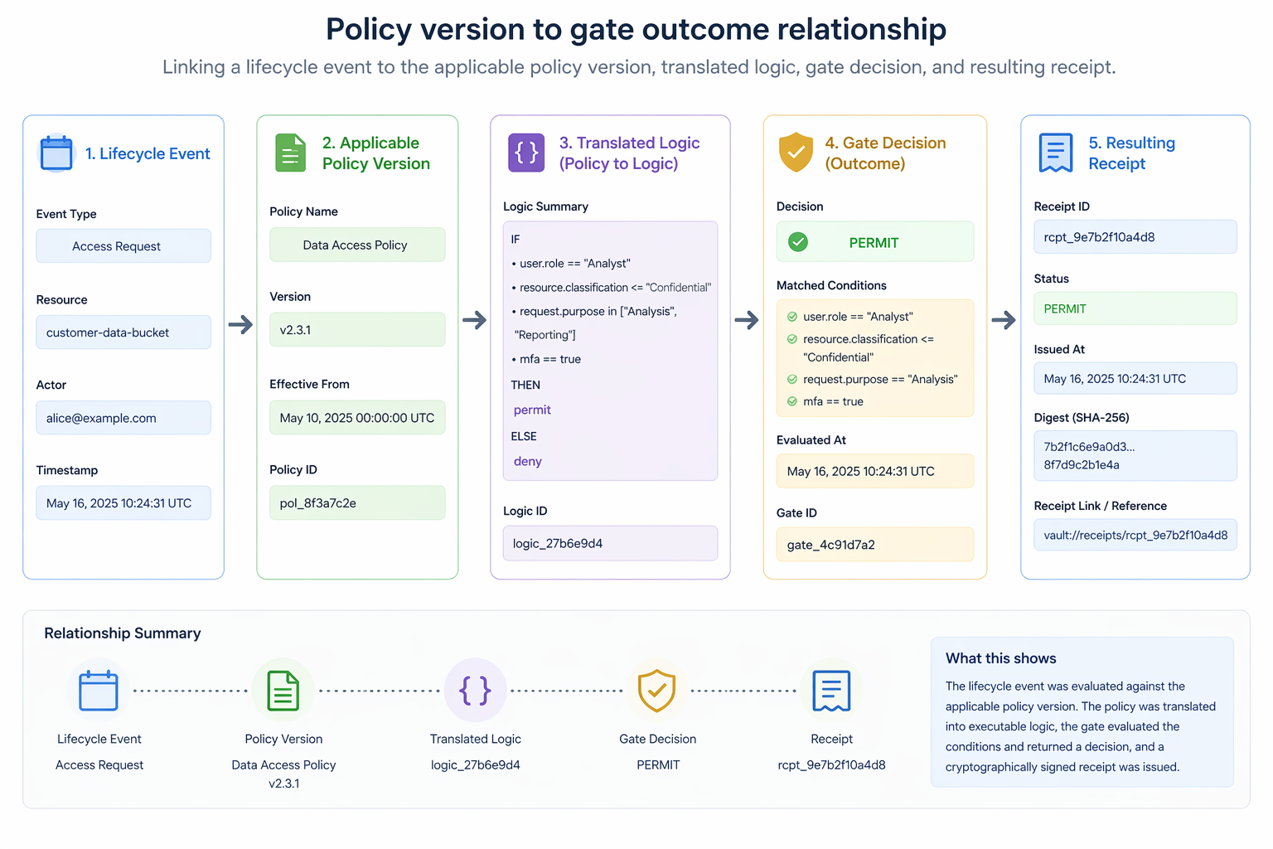
Figure 2. Policy version to gate outcome relationship
: a gate evaluation view that links a lifecycle event to the applicable policy version, translated logic, gate decision, and resulting receipt.

7. Receipts, Policy State, and Vault Commitment
A receipt is the portable evidence object produced by the process. It binds together the lifecycle event, the governing policy version, the gate outcome, and the integrity metadata needed for later verification. In other words, the receipt does not preserve only that something happened; it preserves what happened, under what policy state, through which control result, and with what cryptographic integrity.
The evidence vault then preserves not only receipts, but also the policy versions and linked artifacts that shaped those receipts. This may include supporting approvals, validation outputs, evaluation bundles, exception records, or related lifecycle references. The vault therefore stores both event history and governing context. That is what makes the architecture durable under audit, regulatory review, dispute, or litigation.
This dual preservation - event evidence plus policy state - is one of the strongest differentiators of CIAF - LCM. Without it, later reviewers might be able to see that a system acted, but not whether it acted under the right rules. By preserving both, CIAF - LCM gives the architecture the ability to answer not only what occurred, but whether it occurred under the correct governance conditions.

8. Why CIAF - LCM Matters as a Standalone Process Model
A standalone CIAF - LCM paper matters because it makes several otherwise confusing parts of the broader architecture understandable. It clarifies why gates are not arbitrary checkpoints but the runtime expression of policy. It clarifies why policy versioning is central to auditability, regulatory review, and dispute resolution. It clarifies why receipts must preserve the relationship between lifecycle events, policy state, and control outcome. And it clarifies why the evidence vault stores not only events, but also the governing policy versions that shaped those events.
Without this process framing, readers may incorrectly collapse the architecture into a logging pattern, a workflow tool, or an approval layer. With it, CIAF - LCM becomes legible as executable governance: a repeatable process that moves from policy definition to machine - validated logic, from logic to gates, from gates to receipts, and from receipts to durable evidence.

9. Limitations and Future Work
This paper does not claim that one policy schema, one logic language, or one gate taxonomy will fit every regulated context. Sector - specific extensions will almost certainly be required. Organizations in healthcare, finance, defense, public administration, and general enterprise operations will likely define different governance perimeters and different evidence requirements.
A second limitation concerns translation complexity. Turning human - authored governance policy into machine - evaluable logic is conceptually powerful but operationally demanding. Future work should explore how much can be standardized across sectors, what parts should remain organization - specific, and how assurance profiles can express differences in evidentiary strength.
Finally, the process model should ultimately be tested against operational baselines. Comparative work is needed to evaluate how policy - grounded gates and receipt generation perform in real systems, how organizations manage policy versioning over time, and how effectively the preserved evidence supports audits, reviews, incidents, and disputes.

10. Conclusion
CIAF - LCM is best understood as the process architecture that connects organizational governance policy to machine - evaluable control and durable evidence. By versioning policy, translating it into logic, deriving gates, evaluating lifecycle events, and preserving outcomes as receipts in the evidence vault, the model turns governance from static documentation into executable accountability.
In that sense, CIAF - LCM provides the operating logic that makes AI Governance Evidence Infrastructure coherent as a real implementation model rather than only a conceptual framework. It explains how an organization moves from policy intent to control execution to evidence preservation, and why that sequence is essential for audit, regulatory review, incident reconstruction, and litigation readiness.

References
[1] NIST, Artificial Intelligence Risk Management Framework (AI RMF 1.0), 2023. https://nvlpubs.nist.gov/nistpubs/ai/nist.ai.100 - 1.pdf
[2] EU AI Act Service Desk, "Article 12: Record - keeping," describing logging and traceability obligations for high - risk AI systems. https://ai - act - service - desk.ec.europa.eu/en/ai - act/article - 12
[3] OpenTelemetry Documentation, "What is OpenTelemetry?" and related logs and traces documentation. https://opentelemetry.io/docs/what - is - opentelemetry/

AI uses disclosure:

This document, " Cognitive Insight Audit Framework Lazy Capsule Materialization (CIAF - LCM)," was prepared for concept development and publication planning, dated April 18, 2026. It was authored by Denzil Greenwood, Founder and Head Researcher at CognitiveInsight.ai.
In the creation of this document, AI tools were utilized to generate both the text and the supporting images, with human oversight applied to both processes.

Research Papers and Continued Work: AI Governance Evidence Infrastructure
- Cognitive Insight Audit Framework Lazy Capsule Materialization (CIAF - LCM)
- Tamper - Evident Evidence Vault for AI Lifecycle Events, Decisions, and Audit Packs
- Dual - Layer Provenance for AI - Generated Artifacts: Explicit Watermarks and Forensic Fingerprints as Evidence Infrastructure
- Governance Planes for Agentic AI: Identity, Policy, Privilege, Execution, and Evidence
- Shadow AI Governance: Bringing Unmanaged AI Use into the Evidence Perimeter
- CIAF - LCM Proposed Schema Documentation: Current Schema State, Architecture Fit, and Proposed Documentation Model

